POWER BI

Microsoft Power BI is an interactive data visualization software product developed by Microsoft with a primary focus on business intelligence.
It is part of the Microsoft Power Platform. Power BI is a collection of software services, apps, and connectors that work together to turn various
sources of data into static and interactive data visualizations.
Data may be input by reading directly from a database, webpage, PDF, or structured files such as spreadsheets, CSV, XML, JSON, XLSX, and SharePoint.

What is Power BI used for?
Whether you’re a data pro or are just entering the business world, Power BI is designed to empower you with data-driven insights. Some of the most common uses for the platform include:
- Creating reports and dashboards that present data sets in multiple ways using visuals
- Connecting various data sources, such as Excel sheets, onsite data warehouses, and cloud-based data storage, and then transforming them into business insights
- Turning data into a wide range of different visuals, including pie charts, decomposition trees, gauge charts, KPIs, combo charts, bar and column charts, and ribbon charts – among many other options
- Providing company-wide access to data, data visualization tools, and insights in order to create a data-driven work culture

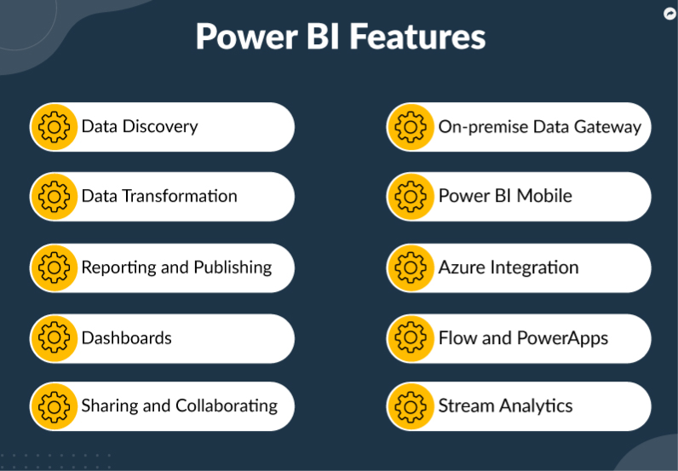

Syllabus

Module | Topics | Hours
Day 1.  Introduction to Power BI and getting started | - Introduction to business intelligence (BI)  - Introduction to Power BI  - Why Power BI ?  - Use Cases  - Power BI Components  - Architecture of Power BI  - Downloading and installing Power BI Desktop  - Data Extraction from different data sources (Excel,CSV,etc)  - Getting Started With Sample Reports | 3
 | - Shaping data using Power Query Editor  Formatting data  Transformation of data  Understanding of Data types  - Creating visuals using different graphs such as bar, line,pie,geographical,tabular etc  - Sample programs and assignment | 3
Day 2  Data Modelling with DAX and Mini project | Introduction of DAX  Why is DAX used?  DAX syntax  DAX functions  Context in DAX  Calculated columns using DAX  Measures using DAX  Calculated tables using DAX  Learning about table, information, logical, text, iterator,  Sample programs and assignment | 3
 | - Building dashboard for a use case and publish the dashboard  - Presentation of the dash board | 3

